CSA1013 – SOFTWARE ENGINEERING shaik Arshad
192425080

- TO CREATE KANBAN BOARDS

AIM: To create a Kanban Board with To Do, In-Progress, and Done columns and simulate task movement.
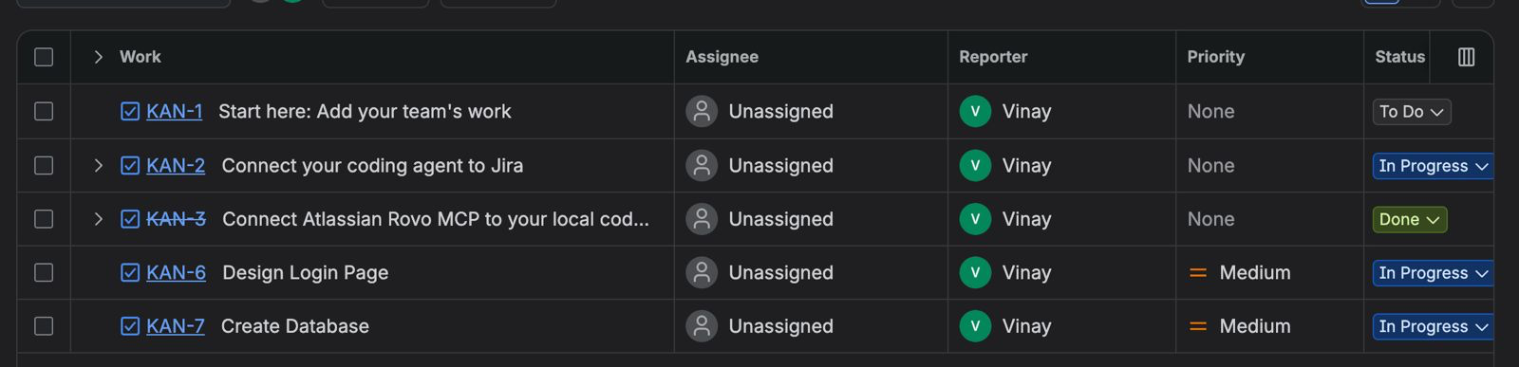

OUTPUT:
Thus, a Kanban board was successfully created using Jira/Trello and tasks were moved across columns to simulate workflow

- SCRUM PROJECT
AIM: To create a Scrum project in Jira, add backlog items, prioritize them, create a sprint, start the sprint, and track progress using the sprint board.
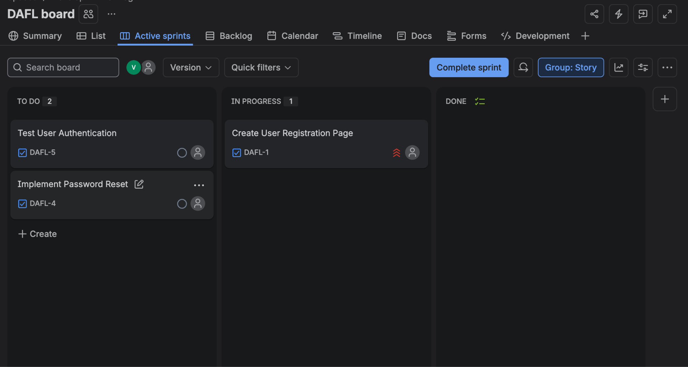

OUTPUT: Thus, a Scrum project was successfully created in Jira with backlog prioritization, sprint planning, sprint execution, and sprint completion

- MoSCoW & Kano techniques
AIM: To categorize and prioritize Online Learning Platform requirements using MoSCoW and Kano techniques in Jira.

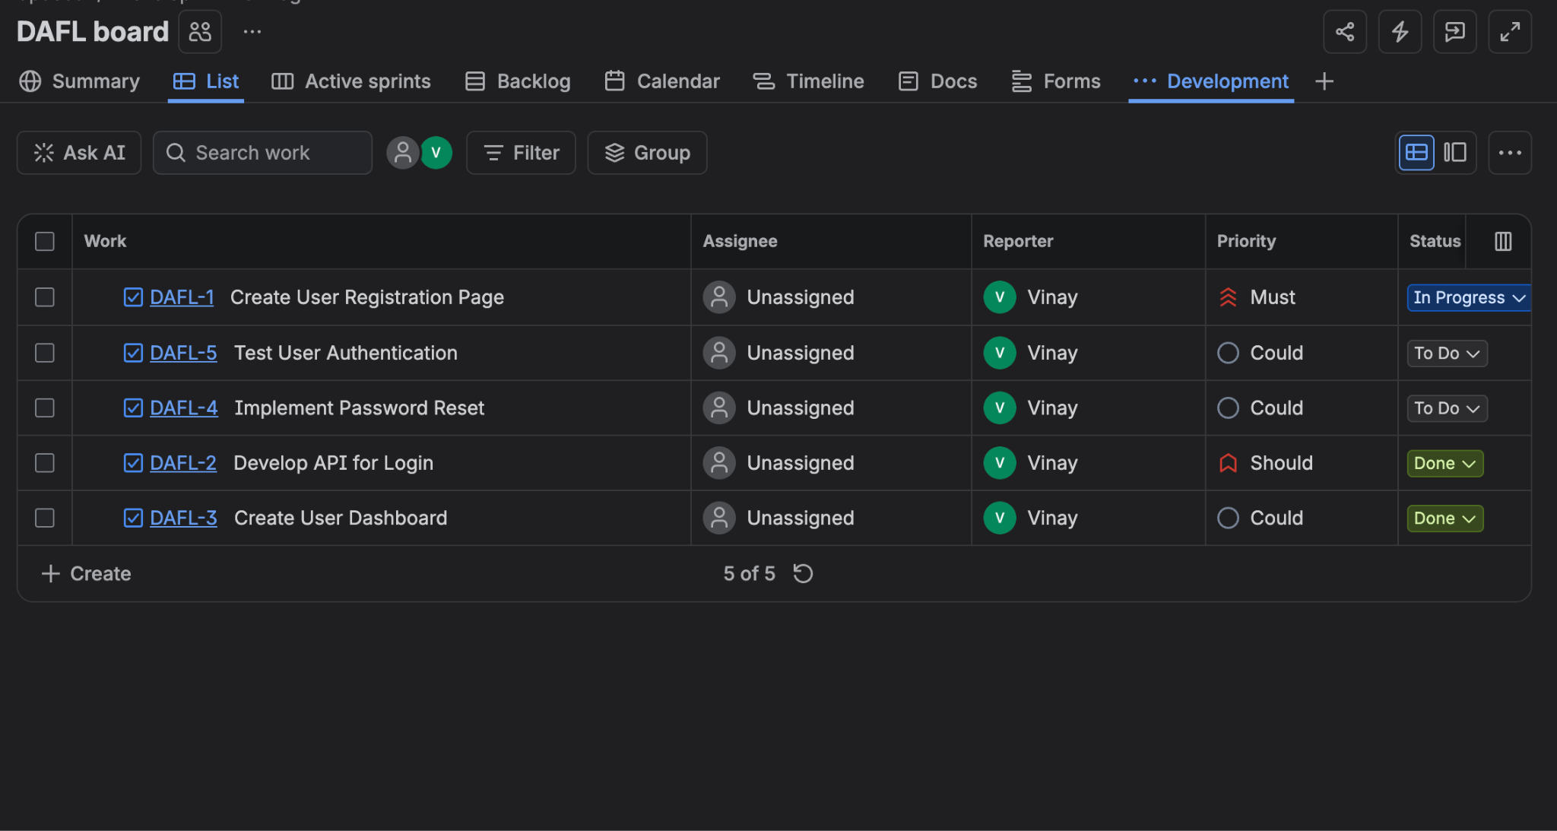

OUTPUT: The Online Learning Platform requirements were successfully categorized and prioritized using MoSCoW and Kano techniques in Jira.

